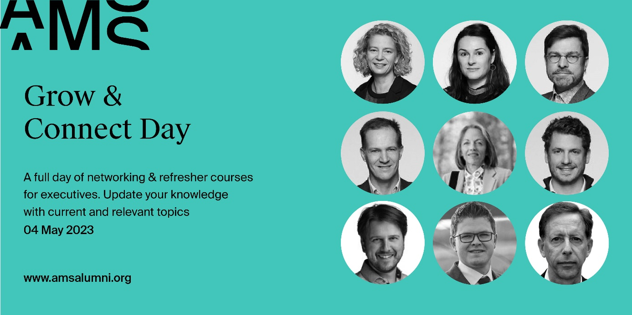
Registration form for individuals
Normal Fee (ex. Btw)
- AMS Alumni: 350 EUR
- Bring a friend: AMS Alumni can register with a partner for 700 EUR total, bringing a friend at our exclusive alumni price!
- Non - Alumni: 750 EUR
Group tickets (5 or more): if your company would like to purchase five or more tickets, we will be happy to offer those at the alumni price of 350 EUR.
please fill in the form below and return it to emmanuelle.duval@ams.ac.be
Each participant will receive an email confirming their registration.

Company details
Company Name:
VAT Number:
Address:
email of the contact person for invoicing:
Participant 1:
Are you an AMS alumnus?
First name:
Last name
Email
Job title:
company name:
What are 2 words that describe your passions?
if you have any dietary restrictions, please indicate them here:
morning session selection: (pick 1)
- Managing the pathways of digital transformation, by Steven De Haes
- Thriving - business strategies to regenerate nature, society and the economy, by Wayne Visser
- Sustainable careers - happy, healthy & productive, by Ans De Vos and Sofie Jacobs
- How to get the price right, by Pol Vanaerde
afternoon sessions (pick 1)
- Building and leading innovative teams, by Robin De Cock
- A journey of a sail trip through a global "perfect storm" in supply chains by Roel Gevaers including live contributions by top experts Koen De Leus (Chief Economist BNP Paribas Fortis) & Prof. Wouter Dewulf (Air freight expert)
- The change manager does not exist – team work makes the dream work, by Daan Sorgeloos (sold out)
- The use of platform businesses in the spurt to a circular economy, by Carla I. Koen

Participant 2:
Are you an AMS alumnus?
First name:
Last name
Email
Job title:
company name:
What are 2 words that describe your passions?
if you have any dietary restrictions, please indicate them here:
morning session selection: (pick 1)
- Managing the pathways of digital transformation, by Steven De Haes
- Thriving - business strategies to regenerate nature, society and the economy, by Wayne Visser
- Sustainable careers - happy, healthy & productive, by Ans De Vos and Sofie Jacobs
- How to get the price right, by Pol Vanaerde
afternoon sessions (pick 1)
- Building and leading innovative teams, by Robin De Cock
- A journey of a sail trip through a global "perfect storm" in supply chains by Roel Gevaers including live contributions by top experts Koen De Leus (Chief Economist BNP Paribas Fortis) & Prof. Wouter Dewulf (Air freight expert)
- The change manager does not exist – team work makes the dream work, by Daan Sorgeloos (sold out)
- The use of platform businesses in the spurt to a circular economy, by Carla I. Koen

Participant 3:
Are you an AMS alumnus?
First name:
Last name
Email
Job title:
company name:
What are 2 words that describe your passions?
if you have any dietary resitrictions, please indicate them here:
morning session selection: (pick 1)
- Managing the pathways of digital transformation, by Steven De Haes
- Thriving - business strategies to regenerate nature, society and the economy, by Wayne Visser
- Sustainable careers - happy, healthy & productive, by Ans De Vos and Sofie Jacobs
- How to get the price right, by Pol Vanaerde
afternoon sessions (pick 1)
- Building and leading innovative teams, by Robin De Cock
- A journey of a sail trip through a global "perfect storm" in supply chains by Roel Gevaers including live contributions by top experts Koen De Leus (Chief Economist BNP Paribas Fortis) & Prof. Wouter Dewulf (Air freight expert)
- The change manager does not exist – team work makes the dream work, by Daan Sorgeloos (sold out)
- The use of platform businesses in the spurt to a circular economy, by Carla I. Koen

Participant 4:
Are you an AMS alumnus?
First name:
Last name
Email
Job title:
company name:
What are 2 words that describe your passions?
if you have any dietary restrictions, please indicate them here:
morning session selection: (pick 1)
- Managing the pathways of digital transformation, by Steven De Haes
- Thriving - business strategies to regenerate nature, society and the economy, by Wayne Visser
- Sustainable careers - happy, healthy & productive, by Ans De Vos and Sofie Jacobs
- How to get the price right, by Pol Vanaerde
afternoon sessions (pick 1)
- Building and leading innovative teams, by Robin De Cock
- A journey of a sail trip through a global "perfect storm" in supply chains by Roel Gevaers including live contributions by top experts Koen De Leus (Chief Economist BNP Paribas Fortis) & Prof. Wouter Dewulf (Air freight expert)
- The change manager does not exist – team work makes the dream work, by Daan Sorgeloos (sold out)
- The use of platform businesses in the spurt to a circular economy, by Carla I. Koen

Participant 5:
Are you an AMS alumnus?
First name:
Last name
Email
Job title:
company name:
What are 2 words that describe your passions?
if you have any dietary restrictions, please indicate them here:
morning session selection: (pick 1)
- Managing the pathways of digital transformation, by Steven De Haes
- Thriving - business strategies to regenerate nature, society and the economy, by Wayne Visser
- Sustainable careers - happy, healthy & productive, by Ans De Vos and Sofie Jacobs
- How to get the price right, by Pol Vanaerde
afternoon sessions (pick 1)
- Building and leading innovative teams, by Robin De Cock
- A journey of a sail trip through a global "perfect storm" in supply chains by Roel Gevaers including live contributions by top experts Koen De Leus (Chief Economist BNP Paribas Fortis) & Prof. Wouter Dewulf (Air freight expert)
- The change manager does not exist – team work makes the dream work, by Daan Sorgeloos (sold out)
- The use of platform businesses in the spurt to a circular economy, by Carla I. Koen

Participant 6
Are you an AMS alumnus?
First name:
Last name
Email
Job title:
company name:
What are 2 words that describe your passions?
if you have any dietary restrictions, please indicate them here:
morning session selection: (pick 1)
- Managing the pathways of digital transformation, by Steven De Haes
- Thriving - business strategies to regenerate nature, society and the economy, by Wayne Visser
- Sustainable careers - happy, healthy & productive, by Ans De Vos and Sofie Jacobs
- How to get the price right, by Pol Vanaerde
afternoon sessions (pick 1)
- Building and leading innovative teams, by Robin De Cock
- A journey of a sail trip through a global "perfect storm" in supply chains by Roel Gevaers including live contributions by top experts Koen De Leus (Chief Economist BNP Paribas Fortis) & Prof. Wouter Dewulf (Air freight expert)
- The change manager does not exist – team work makes the dream work, by Daan Sorgeloos (sold out)
- The use of platform businesses in the spurt to a circular economy, by Carla I. Koen
Participant 7:
Are you an AMS alumnus?
First name:
Last name
Email
Job title:
company name:
What are 2 words that describe your passions?
if you have any dietary restrictions, please indicate them here:
morning session selection: (pick 1)
- Managing the pathways of digital transformation, by Steven De Haes
- Thriving - business strategies to regenerate nature, society and the economy, by Wayne Visser
- Sustainable careers - happy, healthy & productive, by Ans De Vos and Sofie Jacobs
- How to get the price right, by Pol Vanaerde
afternoon sessions (pick 1)
- Building and leading innovative teams, by Robin De Cock
- A journey of a sail trip through a global "perfect storm" in supply chains by Roel Gevaers including live contributions by top experts Koen De Leus (Chief Economist BNP Paribas Fortis) & Prof. Wouter Dewulf (Air freight expert)
- The change manager does not exist – team work makes the dream work, by Daan Sorgeloos (sold out)
- The use of platform businesses in the spurt to a circular economy, by Carla I. Koen

